**185. An Example Form**

* -: So here I am on a simple example form just to get started .

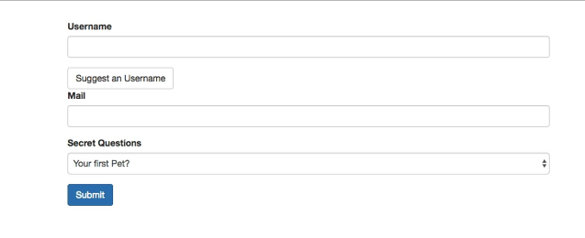

* The code responsible for it is this HTML code in the template of my app component here and you can find this code attached to this lecture here .

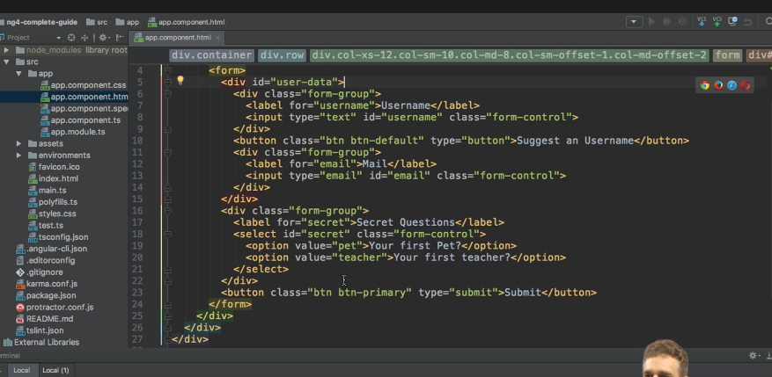

* Now, it's a simple form .
* We're going to expand it or enhance it with some features throughout this module .
* To get started, this is just fine .
* Now, if we have a look at this HTML code, you will quickly realize that on the form tag here I don't have the action attribute pointing to some route .

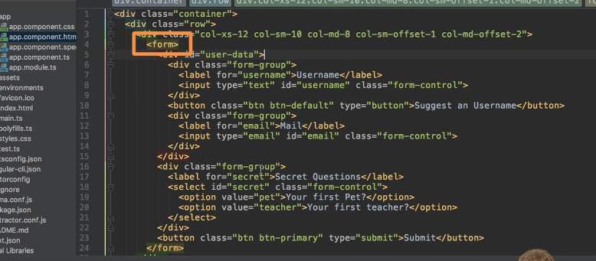

* *I'm also not specifying the method attribute which typically would be post .*
* ***The reason for this is that this form should not get submitted to a server .***
* I don't want a HTTP request to be the result of me clicking the submit button .
* *Instead, as mentioned earlier, Angular should handle this form, and therefore I don't have a action on it .*
* This, of course, means that right now if I hit the submit button, nothing happens .
* If you have a look at the refresh icon up there, you see it's not spinning .
* *Nothing happens because we're not actually sending a request .*
* Well, we will work on this, but first, let's understand what actually happens behind the scenes and how Angular infers Sencha forms, create such a JavaScript object for us, as it does when using the template driven approach .
* Let's understand how we get Angular cue creators form object for us .